Task No: 3  Date: | Perform Data Cube Operations (OLAP Operations) using SQL Queries Rollup, Rolldown, Slicing, Dicing  Database: MySQL

AIM
To Perform Data Cube Operations (OLAP Operations) using SQL Queries Rollup, Roll down, Slicing, Dicing

PROCEDURE
- create the sales.sales_summary table by using the following query:
SELECT
b.brand_name AS brand,
c.category_name AS category,
p.model_year,
round(
SUM (
quantity * i.list_price * (1 - discount)
),
0
) sales INTO sales.sales_summary
FROM
sales.order_items i
INNER JOIN production.products p ON p.product_id = i.product_id
INNER JOIN production.brands b ON b.brand_id = p.brand_id
INNER JOIN production.categories c ON c.category_id = p.category_id
GROUP BY
b.brand_name,
c.category_name,
p.model_year
ORDER BY
b.brand_name,
c.category_name,
p.model_year;

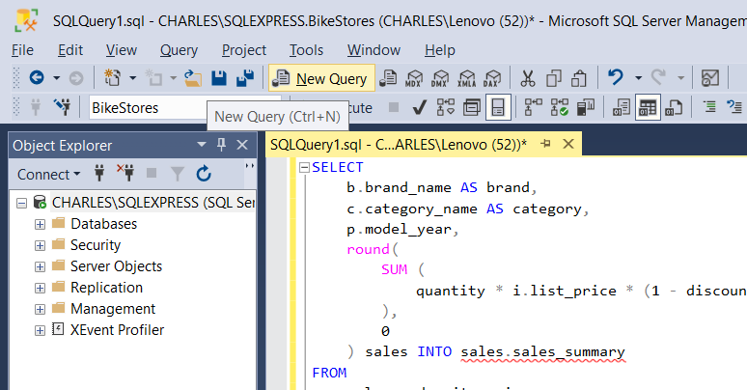
- CUBE:
Refer task 2a:
The CUBE is a subclause of the GROUP BY clause that allows you to generate multiple grouping sets. The following illustrates the general syntax of the CUBE:
SELECT
d1,
d2,
d3,
aggregate_function (c4)
FROM
table_name
GROUP BY
d1,
CUBE (d2, d3);

Example:
SELECT
brand,
category,
SUM (sales) sales
FROM
sales.sales_summary
GROUP BY
CUBE(brand, category);

- ROLLUP
Refer task 2a:
SQL Server ROLLUP syntax
The general syntax of the SQL Server ROLLUP is as follows:
SELECT
d1,
d2,
d3,
aggregate_function(c4)
FROM
table_name
GROUP BY
ROLLUP (d1, d2, d3);
Upload and configure the sample data warehouse (refer task2a)
Select the New Query, then new query tab will be opened.
ROLLUP Query
SELECT
brand,
category,
SUM (sales) sales
FROM
sales.sales_summary
GROUP BY
ROLLUP(brand, category);

- DRILLDOWN
This is a reverse of the ROLL UP operation. The data is aggregated from a higher level summary to a lower level summary/detailed data.
SELECT
brand,
category,
SUM (sales) sales
FROM
sales.sales_summary
GROUP BY
ROLLUP(brand, category)
HAVING SUM (sales) > 20000;

- SLICING:
A slice in a multidimensional array is a column of data corresponding to a single value for one or more members of the dimension. It helps the user to visualize and gather the information specific to a dimension.
SELECT
*
FROM
sales.customers
WHERE
state = 'CA';

- DICING:
Dicing is similar to slicing, but it works a little bit differently. Dicing, on the other hand, is more of a zoom feature that selects a subset over all the dimensions, but for specific values of the dimension.
SELECT
city,
COUNT (*)
FROM
sales.customers
WHERE
state = 'CA'
GROUP BY
city
HAVING
COUNT (*) > 10
ORDER BY
city;

- PIVOT
The steps to make a query a pivot table:
- First, select a base dataset for pivoting.
- Second, create a temporary result by using a derived table or common table expression (CTE)
- Third, apply the PIVOT operator.

- First, select category name and product id from the production.products and production.categories tables as the base data for pivoting:
SELECT
category_name,
product_id
FROM
production.products p
INNER JOIN production.categories c
ON c.category_id = p.category_id

- Second, create a temporary result set using a derived table:
SELECT * FROM (
SELECT
category_name,
product_id
FROM
production.products p
INNER JOIN production.categories c
ON c.category_id = p.category_id
) t

- Third, apply the PIVOT operator:
SELECT * FROM
(
SELECT
category_name,
product_id
FROM
production.products p
INNER JOIN production.categories c
ON c.category_id = p.category_id
) t
PIVOT(
COUNT(product_id)
FOR category_name IN (
[Children Bicycles],
[Comfort Bicycles],
[Cruisers Bicycles],
[Cyclocross Bicycles],
[Electric Bikes],
[Mountain Bikes],
[Road Bikes])
) AS pivot_table;

RESULT:

Thus the Data Cube Operations (OLAP Operations) using SQL Queries Rollup, Roll down, Slicing, Dicing, Pivot was executed using SSMS and SQl Server.

